Aldous Benjamin A. Maranga BDSE07-0922-120

Source Code: <https://drive.google.com/file/d/1TFfNH1Rz5N0pTeGAEQx-yUG2pXeRpppG/view?usp=share_link>

1. Setup NodeJS

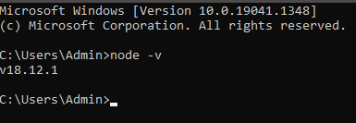

1. Setup an Angular Project using Angular CLI

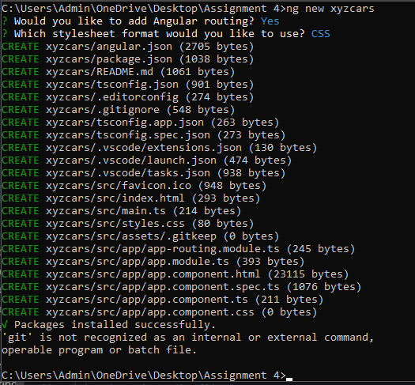

1. Run the Angular Project using ng serve --open

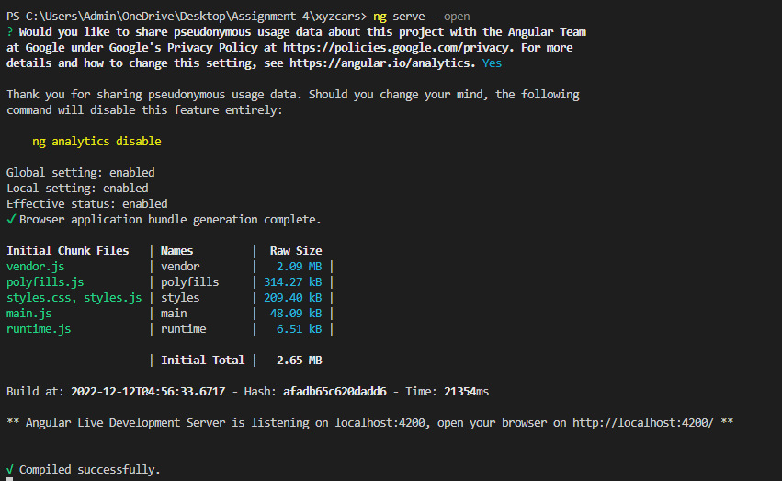

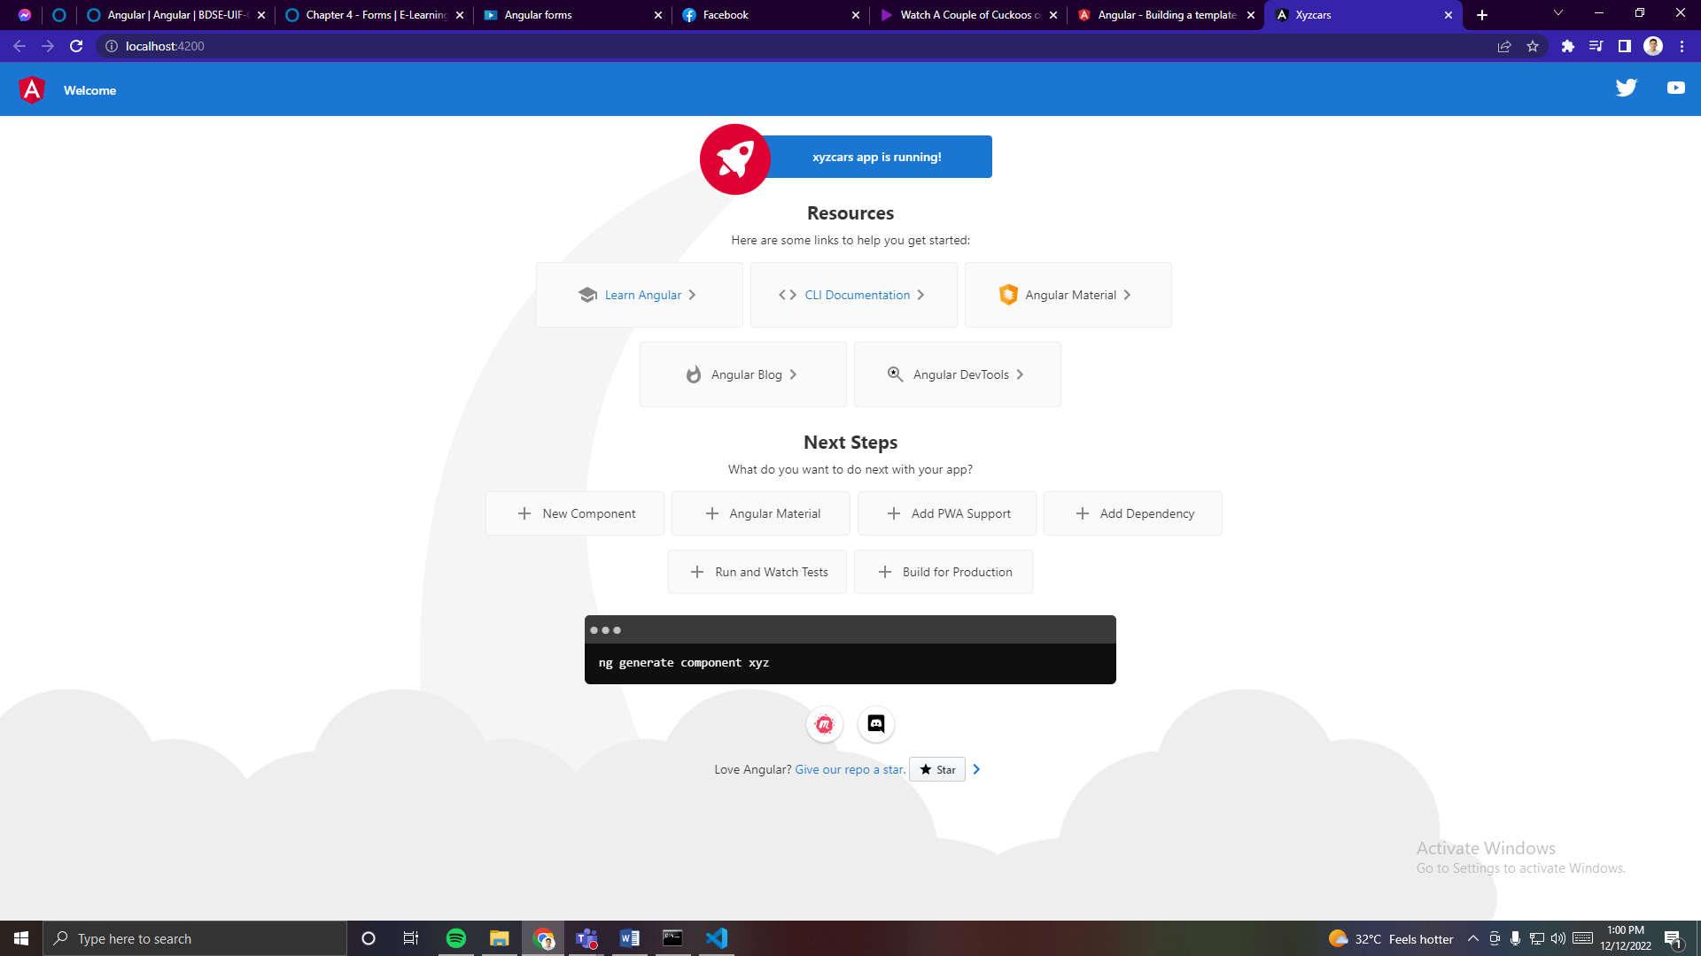

1. Provide the script to generate an Angular Component using Angular CLI

ng generate component ComponentName

1. Generate an Angular Component called WelcomeComponent

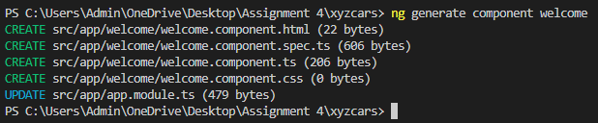

1. Include the text “Welcome to XYZ Cars…” in the component

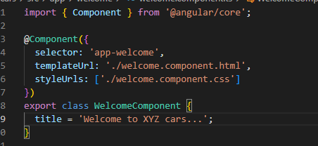

1. Include the Component created as part of AppComponent
2. Create 2 Components
3. One for displaying Cars on Sale

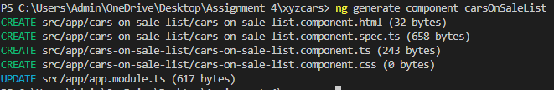

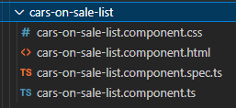

1. Details of a car which is being clicked

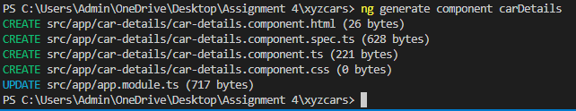

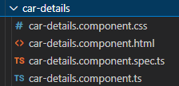

1. Configure 2 routes

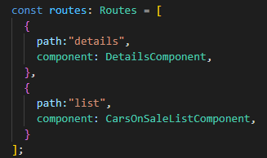

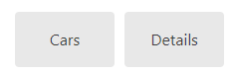

1. Create a custom Service to provide test Car Data with 3 fields, Make, Model, Year, Description and Car Photo and subscribe to the service

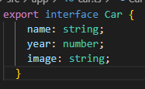

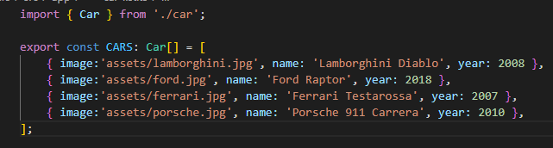

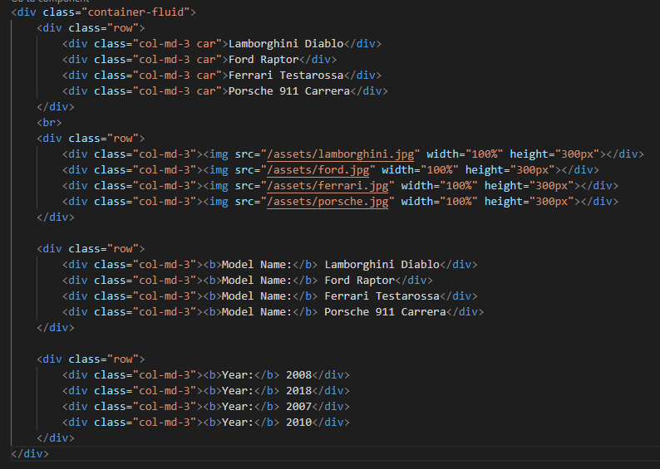

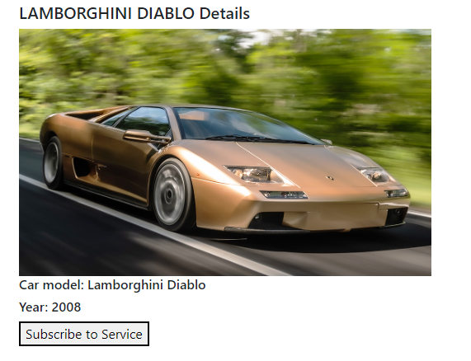

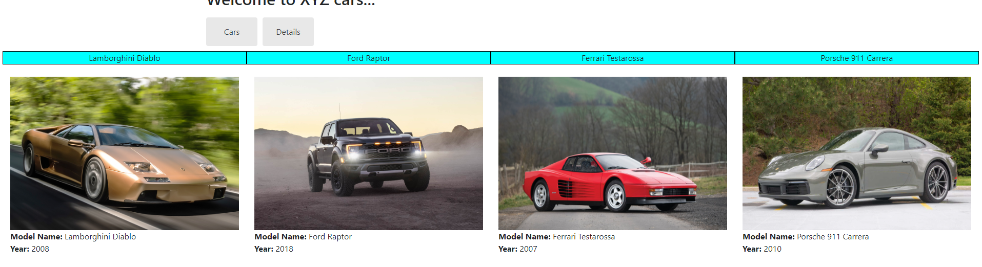

1. Include the 2 Components in the AppComponent

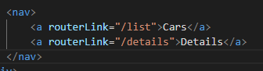

1. The final project should have a Welcome Screen, List of Car Screens and Car details Screen

